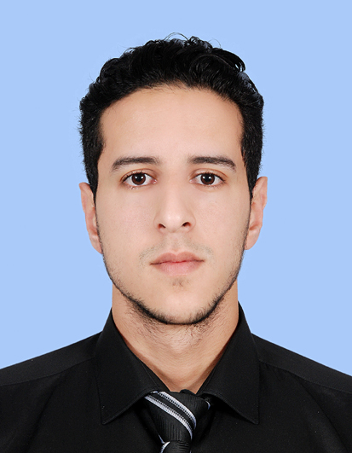

Curriculum vitae
Personal information :

- Last name : Dalil
- First name : Zakaria

Nationality : Moroccan

Marital status : Single
- Date of birth : 07/26/1992

Education and Training

- April, 2017: CELTA from the International Training Institute in Istanbul, Turkey.
- 2013-2015: Master’s degree in “Communication Studies” from Moulay Ismail University, Meknes, Morocco.
- May, 2015: Co-organizer and participant in “Study day: Interfaith dialogue” Meknes, Morocco.
- February- June 2015: Intensive courses in Public relations, Media Studies, intercultural communication and academic research skills.
- 2010-2013: B.A. in English Studies from the University of Ben Msik Casablanca, Morocco.
- July, 2013: Internship at leadership in Camp Excel, Casablanca, Morocco.
- March, 2013: Internship at “The Employability Course “in collaboration with the British Council.
Work Experience

- October 2018- still on it: English teacher at Zhengzhou university for Aeronautics, Zhengzhou, china

- September 2020- still on it: Part time English teacher at Henan medical university, Zhengzhou, china

- October 2017- June 2018: English Instructor at Uskudar University, Istanbul, Turkey.

- October- May: Part-time English teacher at American Culture Language Center, Istanbul, Turkey.

- June- August 2017: English teacher at American Culture Language Center in Istanbul, Turkey.

- Mai- November 2016: IP correspondent for JAH & Co. IP Company for Intellectual Property in Doha, Qatar

- October 2015- Mai 2016: English teacher at British Workshop language school, Casablanca, Morocco.

- October 2015- Mai 2016: IELTS and TOEFL trainer at the British Workshop language school.

- January- June 2015: English teacher at El Hanin school, Meknes, Morocco.

- June 2015: head and participant of the undergrad teaching project.

- July- August 2014: Field investigator in the 2014 Census of the population.

- January- May 2014 : English teacher at Al Anwar school, Meknes, Morocco.

- June- August 2012 and 2013 : Tourist guide in Ifni Dream association, Sidi Ifni, Morocco.

- Freelance Translator and interpreter.

IT Skills

- Excel, Word, Power point, Outlook.

- Fast blind typing

- Online research Skills.

Languages

- Arabic : Mother Tongue
- French : Good
- English : Fluent
- Japanese : Pre-intermediate

