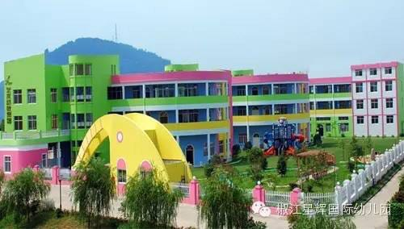

FOREIGN TEACHER/EXPERT REQUIREMENTS
Name of Institution in English
XingHui International Kindergarten
DETAILED EMPLOYMENT PACKAGE
PERTINENT INFORMATION IS HIGHLIGHTED IN BLUE

Gender | √ Unspecified
Education Background | √ Bachelor
Major Required | √ Unspecified
Preferred Nationality | √ USA √ UK √ Canada √ Australian
Age limit | √ 22-35
Preferred Starting Time | √ March
2. SPECIFIC SCHOOL DETAILS

Can friends and relatives visit the teacher at the school | √  Yes (and are encouraged to)
What is the name of the nearest large city? | City：TAIZHOU  Population： --6--Million
Is the school located in the downtown area? | √ Yes  □No ___ minutes away by bus
Temperature City range | Summer 20 C —— 30 C  Winter 0 C —— 15 C
What level of Institution is the school? | √ Kindergarten
How many students per class (on average)? | √25
What is the Students English level？ | √ Beginner
Will the school provide the teaching curriculum? | √ Yes
What Course is the foreign teacher expected to teach? | √ Oral √ Reading √ Listening
What teaching materials/aids should teachers bring with them to China and the school? | Teachers are free to incorporate learning activities and games as part of their teaching. Materials that provide an insight into the Foreign Teachers country, its customs and culture, are encouraged. Teachers are also encouraged to bring with them materials such as newspapers, magazines etc. that provide information on “western” culture and society as well as DVD’s etc. of television programs etc.  Materials such as favorite sports teams’ uniforms, and favorite board games are more than welcome.

111
3. WHAT FACILITIES ARE AVAILABLE AT THE SCHOOL OR CLOSE TO THE SCHOOL?

Supermarkets | √ Yes □No | Theaters |  |  | √ Yes □No
Restaurants | √ Yes □No | Library (English) |  |  | □Yes √ No
Hospital | √ Yes □No |  | Gymnasium for use by teachers |  |  | Yes √ No
Cafe Western Restaurants and food available? | √ Yes No |  | Dining Room for teachers |  |  | Yes √ No
Night Club/Disco | √ Yes □No |  | Train station  Bus Station |  |  | √ Yes □ No
In an emergency, how far is it to the best medical facilities? |  |  |  | ____5__Minutes walk
Are there Medical Facilities available? |  |  |  | √ Yes □No
4. FOREIGN TEACHER’S WORK SCEHDULE

Type of Position | √ Full Time
How many class hours per week？ | 25 Classes/week
What is the duration of each class? | 30 Minutes/class
What is the monthly salary to be paid to the teacher? | 10,000 to 15,000 Monthly salary after tax ( housing allowance is not included in the package )
How many days per week will the teacher being teaching? | 5 Days per week
Type of work schedule | √ Five days a week
What time of day are the classes | √ Weekday evenings and weekend daytime.
When is the pay day each month? | √ The 15th day of the next month.
Will the school reimburse teachers airfare? | √ Yes (return airfare on completion of each contract)
When will the school reimburse a teachers airfare? | √ Upon completion of the contract
Has the school employed Foreign Teachers before? | √ Yes □No
When will the employment contract be offered the teacher?  Will the school provide the teachers Chinese Z Working Visa documentation | √ Before the teacher’s arrival  √ Yes □No
Will the school organize a friendly Bank Account? | √ Yes □No
Will the school, upon the teacher’s arrival, provide the teachers Chinese Residency Permit and Foreign Experts Certificate? | √ Yes □No
What is the contract period | √ a year
If two semesters, can the teacher remain on school premises during holiday periods? | √ Yes □No
Will the school provide airport pick up service? | √ Yes □No
Will the school provide medical insurance? | √ Yes □No
5. SANCTIONED HOLIDAY SCHEDULE

What holidays does the school provide over the contract period? | √ All National Holidays (these are National Day, Dragon Boat Day, Mid Autumn Festival, Ancestors Day, May Day)  √ New Years Day  During Chinese new year (1 week) depending on public school schedules.
Does the teacher get paid over the holidays? | √ Yes

6. DETAILS RELATING TO THE FOREIGN TEACHERS APARTMENT

The school will provide assistance in finding the teacher an apartment when they arrive.
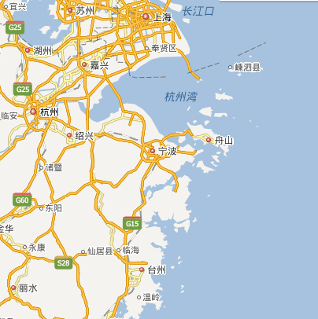
This employment package forwarded to the foreign teacher is a summary of what is offered to the teacher by the school in return for his/her services.
ShangHai

HangZhou
TaiZhou

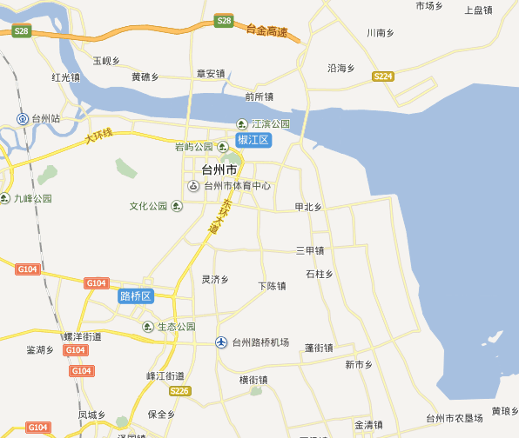
JiaoJiang is the capital city of TaiZhou

JiaoJiang

This is XingHui International Kindergarten

